**#Percentile Report of 10th Marks:**

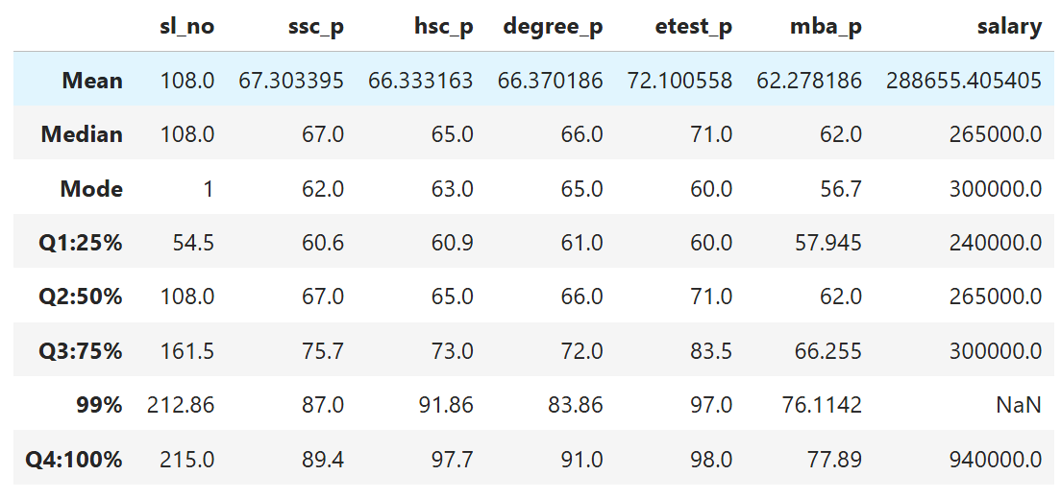

#Percentile of 25% of data of 10th Pass Marks exist in 60.6

#Percentile of 50% of data of 10th Pass Marks exist in 67.0

#Therefore 25% of the Students has only 7% increase in their marks

#Percentile of 75% of data of 10th Pass Marks exist in 75.7

#Therefore 25% of further Students has only 8% increase in their marks

#Percentile of 99% of data of 10th Pass Marks exist in 87.0

#Therefore 24% of further Students has 12% increase in their marks

#Percentile of 100% of data of 10th Pass Marks exist in 89.4

#Therefore 1% of further Students has 2% increase in their marks